

**PES UNIVERSITY**

***(Established under Karnataka Act No. 16 of 2013)***

***100 ft Ring Road Campus, Bengaluru – 560 085, Karnataka, India***

*Assignment on*

“Write a code to plot a DT Signal. Write a code to find the Z- transform and Write a code to find the Inverse Z-Transform using Partial Fraction Expansion method/Long Division Method Only”

**Submitted by**

Manthan BT

PES1UG22EC907

***For the partial fulfilment of the course SAS***

***(Signals and Systems)***

**UE22EC243A**

Electronics and Communication Engineering

**Submitted to**

Dr. Manikandan J

Faculty of Engineering

(Program: B.Tech)

**CODE:**

% Define the DT signal

n = -5:5; % Time index

x = [1,3,2,4,-2,-1,-3,2,1,0,1]; % DT signal

% Plot the DT signal

figure;

stem(n, x);

title('Discrete Time Signal');

xlabel('n');

ylabel('x[n]');

% Find the Z-transform using the Symbolic Math Toolbox

syms z;

X = sum(x.*(z.^-n));

% Display the Z-transform

disp('Z-Transform:');

pretty(X);

% Calculate the Inverse Z-Transform using Partial Fraction Expansion

% Convert symbolic expression to polynomial coefficients

[num, den] = numden(X);

num = sym2poly(num);

den = sym2poly(den);

% Perform Partial Fraction Expansion

[r, p, k] = residue(num, den);

% Display the residues 'r', poles 'p', and direct terms 'k'

disp('Inverse Z-Transform:');

disp('Direct Terms:');

disp(k);

disp('Residues:');

disp(r);

disp('Poles:');

disp(p);

% Calculate the Inverse Z-Transform from the residues and poles

x_inv = zeros(size(n));

for i = 1:length(n)

x_inv(i) = sum(r.' .* ((p.').^n(i)));

end

**OUTPUT:**

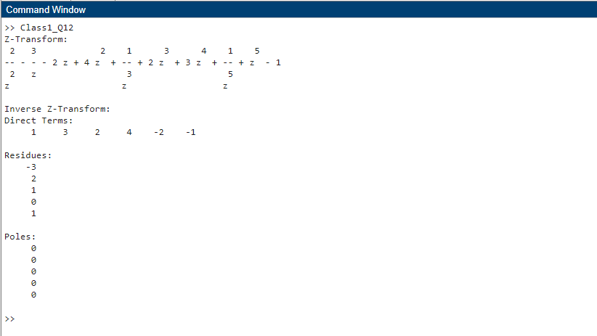

**GRAPH:**

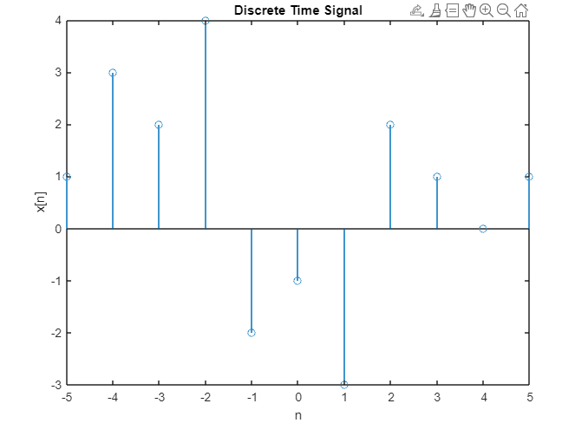

**PROOF:**

